**SOFTWARE REQUIREMENT SPECIFICATION**

**DOCUMENT**

**LIBRARY MANAGEMENT SYSTEM**

**Version:** Version 2.0

**ABSTRACT**

This document is intended to be the SRS for develop **LIBRARY MANAGEMENT SYSTEM**

|  |  |  |  |
| --- | --- | --- | --- |
| **Project Title** | **LIBRARY MANAGEMENT SYSTEM** | | |
| **Lead Institution** | **THE INTERNATIONAL SCHOOL - DUY TAN UNIVERSITY** | | |
| **Project Mentor** | **Mr. Nguyen Dang Quang Huy** | | |
| **Team Name** | **Team 6** | | |
| **Team Members** | **Tuong Thi Thuy Hang** | | |
| **Duong Quang Tuyen** | | |
| **Nguyen Ngoc Minh** | | |
| **Nguyen Nhat Nguyen** | | |
|  | | |
| **Start Date** | Nov 17,2021 | **End Date** | Jan 22,2022 |

**ROPRIETARY INFORMATION**: The information contained in this document is the property of **TEAM 6**. Except as specifically authorized in writing by **TEAM 6**, the holder of this document shall keep all information contained herein confidential and shall protect same in whole or in part from disclosure and dissemination to all third parties

**Table of Contents**

Revision History 4

1. Introduction 6

1.1. Purpose 6

1.2. Intended Audience and Reading Suggestions 6

1.3. References 6

2. Project Overview 6

2.1. Project Description 6

2.2. Business Need 7

2.3. Project Analyst 7

2.3.1. Business Function Diagram 7

2.3.2. System Context Diagram 8

2.3.3. Data Flow Diagram 9

2.4. Software Requirement Specification 11

2.4.1. High level Fucntional Requirement (FR) 11

2.4.2. Stakeholders 13

2.4.3. Usecase 14

2.4.3.1. <<Library Management>> Use Case Diagram Overview 15

2.4.4. List of use cases 15

2.4.5. Use Case Specification 15

*UC 01: Login* 15

*UC 02: Search books* ....17

*UC 03: Borrow books* 18

*UC 04: Manage books* 20

*UC 05: Receive return books* 22

*UC 06: Manage readers* 24

*UC 07: Search information about readers* 25

*UC 08: Statistical report on borrowing books* 26

*UC 09: Make a reader card* 28

*UC 10: Card renewal for readers* 29

*UC 011: Reader statistics report* 31

*UC 012: Report ,statistics of books received* 33

2.4.6. Software Quality Attributes 35

2.4.6.1. Usability 35

2.4.6.2. Reliability 35

2.4.6.3. Security 35

2.4.6.4. Maintainability 35

2.4.6.5. Portability 35

2.4.6.6. Performance 35

2.5. Software Design Description 36

2.5.1. Sequence Diagrams 36

2.5.1.1.

2.5.1.2.

2.5.2. Activity Diagrams 42

2.5.2.1.

2.5.3. Class Diagram 51

Appendix A: Glossary 51

# Revision History

|  |  |  |  |  |
| --- | --- | --- | --- | --- |
| **Date** | **Change Iterm** | **Description** | **by** | **Version** |
| **21/11/2021** | Get requests from customers | After preparing the questions about the request and received the request from the customer | Tuong Thi Thuy Hang | Version 1.0 |
| **22/11/2021** | Start team meeting | Meet and refer to a number of training points, read through the training points and focus on project implementation, the team can fully understand the system requirements to create | Tuong Thi Thuy Hang , Duong Quang Tuyen , Nguyen Nhat Nguyen , Nguyen Ngoc Minh | Verison 1.0 |
| **22/11/2021** | Job analysis | Through specific requirements, analysis, clearly speaking, the leader needs to prepare in advance for the members. | Tuong Thi Thuy Hang | Verison 1.0 |
| **23/11/2021** | Share the work | Get BFD, contextual diagram, DFD level 1, DFD level 2,  The mandatory rules of the project | Tuong Thi Thuy Hang , Duong Quang Tuyen , Nguyen Nhat Nguyen , Nguyen Ngoc Minh | Verision 1.0 |
| **24/11/2021** | Mr. Huy corrected | Fix BFD, DFD, USE CASE, font size, font pattern, context diagram, more clearly about the missing and suggest some important things | Tuong Thi Thuy Hang | Verision 1.0 |
| **25/11/2021** | Editing group | BFD, DFD, USE CASE, Context Diagram, font size, font | Tuong Thi Thuy Hang , Duong Quang Tuyen , Nguyen Nhat Nguyen , Nguyen Ngoc Minh | Verision 1.0 |
| **26/11/2021** | Complete DFD, System Context Diagram | DFD 1 and 2, System Context Diagram | Tuong Thi Thuy Hang , Duong Quang Tuyen , Nguyen Nhat Nguyen , Nguyen Ngoc Minh | Verision 2.0 |
|  |  |  |  |  |

# Introduction

## Purpose

This documentation describes a library management system including all needed information and feature materials in detail for implementation. The purposes of this document are as below:

* To supports the project manager having an overview of the system as well as doing project estimation
* To describes the architectural drivers and use cases in details. Based on this document, architect analyst and designer will be able to implement the system easily.
* To supports tester (QC) writing acceptance test and test plan.

## Intended Audience and Reading Suggestions

|  |  |
| --- | --- |
| **Intended Audience** | **Reading Suggestions** |
| Project manager | High level functional requirement, business constraints for estimation |
| Architect analyst and designer | Overall description and user cases to architect and design the system |
| Quality control | Overall description and user cases to make test plan and write acceptance test |
|  |  |

## References

# Project Overview

## Project Description

## Information Technology has revolutionized the life of human beings and has made lives easier by the various kinds of applications. In the light of the rapid changes with the use of Information Technology, there are many tools,technologies and systems that have been produced and invented.

## This project is concerned with developing a Library Management System for Duy Tan Library in order to make library management more efficient and easy to handle. The Library management system enables a fully automated library service. The goals of this project are to provide simplicity as well as security and efficiency to the management of Duy Tan Library and also reduce managing personnel in the library.

## Business Need

This system had a number of advantages:

- Support librarians in professional tasks such as book management, managing readers faster and more efficiently.

- Support the work of searching for books to quickly access operations for readers.

- The program has all the requirements from the Duy Tan library, has the ability to maintain and upgrade.

- Easy-to-use interface.

## Project Analyst

### Business Function Diagram

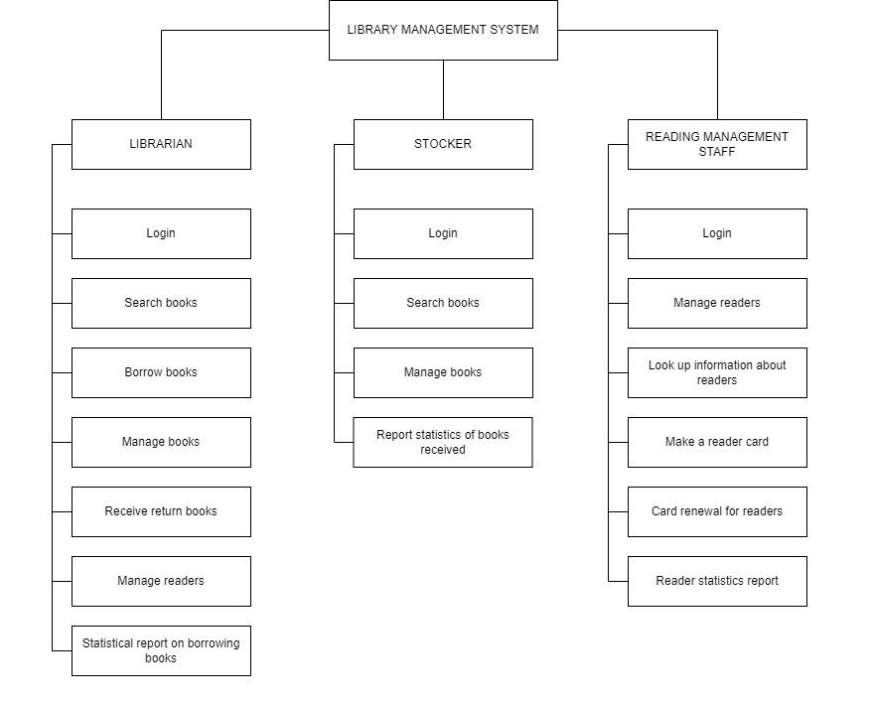

### System Context Diagram

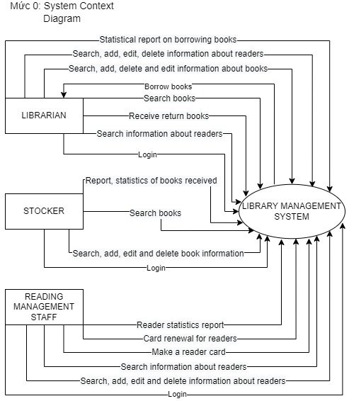

## Software Requirement Specification

### High level Functional Requirement (FR)

|  |  |  |
| --- | --- | --- |
| FR1.1 | **Title** | **Login** |
| All Actor | Actor uses this Use Case to perform login to the system. |
| Description | The system displays the login interface, the user enters the account including the username and password, the system checks and confirms the login information, displays the main interface of the software, ends the use case |
| FR1.2 | **Title** | **Search books** |
| Librarian,Stocker | This use case enables users to search for books by category, title, author,book code, or publisher. |
| Description | The use case begins when a user wishes to search for a book in the system.The user chooses the search function to realize this action.  The system requests the user to select search criteria  The system queries the database to fetch the book details and displays the results to the user. |
| FR1.3 | **Title** | **Borrow books** |
| Librarian | This use case allows librarians to issue books to readers |
| Description | The use case begins when the librarian wishes to issue/lend books to a readers.The librarian chooses add lending function to realize this action.  The system asks the librarian to enter the readers R_code to verify their details in the system.  The system asks the librarian to enter the B_code to check the availability of this book.  The system asks the librarian to enter additional information such as loan date and due date.  In addition, the librarian provides this detailed information, the update system borrows |

### Stakeholders

|  |  |
| --- | --- |
| **Stakeholder** | **Description** |
| Users (Librarian , Stocker , Reading management staff ) | System users |

### Use case

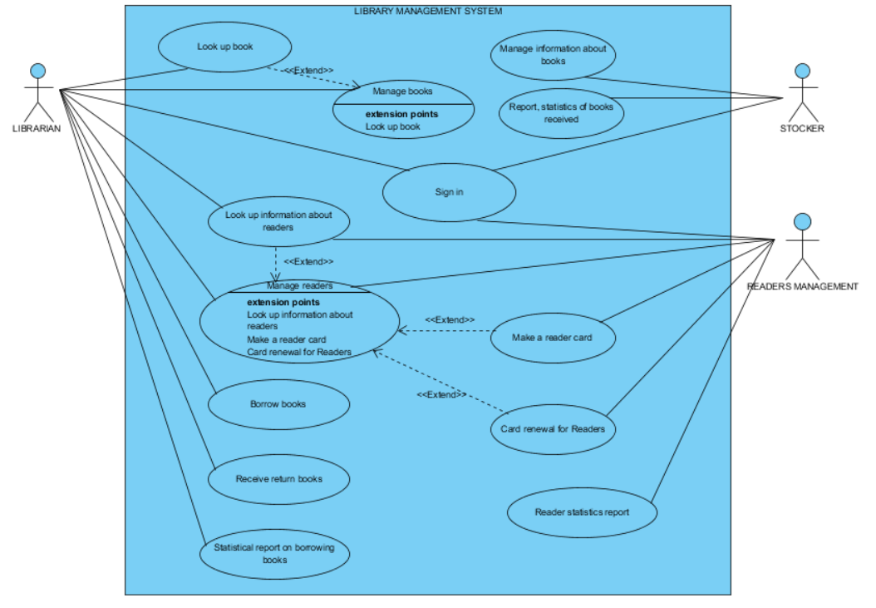

### List of use case

|  |  |  |
| --- | --- | --- |
| **Use case ID** | **Use case name** | **Functional Req.** |
| UC.01 | Login | FR.1 |
| UC.02 | Search books | FR.2 |
| UC.03 | Borrow books | FR.3 |
| UC.04 | Manage books | FR.4 |
| UC.05 | Receive return books | FR.5 |
| UC.06 | Manage readers | FR.6 |
| UC.07 | Search information about readers | FR.7 |
| UC.08 | Statistical report on borrowing books | FR.8 |
| UC.09 | Make a reader card | FR.9 |
| UC.10 | Card renewal for readers | FR.10 |
| UC.11 | Reader statistics report | FR.11 |
| UC.12 | Report ,statistics of books received | FR.12 |

**2.4.5.Use Case Specification**

##### UC 01: Login

1. Use Case Diagram

Login

User

1. Use Case Specification

|  |  |  |  |  |  |
| --- | --- | --- | --- | --- | --- |
| **Use case ID** | UC.01 | | | | |
| **Use case name** | **Login** | | | | |
| **Create by** | Thuy Hang | | **Last updated by** | | Thuy Hang |
| **Date created** | November 24, 2019 | | **Date last updated** | | November 25,2019 |
| **Actor** | Users of the system, including: Librarian,Stocker,Reading Management Staff | | | | |
| **Description** | This use case shows the process followed by a user before login into the Library Management System | | | | |
| **Trigger** | Click to “**Login**” in navigator at home page | | | | |
| **Pre-condition** | None | | | | |
| **Post-condition** | If the use case is successful, an actor is logged into the system.The system state remains unchanged if the use case was not carried out. | | | | |
|  | **Step** | **Actor Action** | | **System Response** | |
| 1 | Click to “**Login**” in navigator at home page | | Redirect to Login page | |
| 2 | Fills all mandatory data fields | |  | |
| 3 | Click to “**Login**” button. | | Announcing the success and allowing the User to log in to the system, the system will decentralize the user according to the account | |
| **Alternative Scenario** | **Step** | **Actor Action** | | **System Response** | |
| 1 | Click to “**Login**” in navigator at home page | | Redirect to Login page | |
| 2 | Fills all mandatory data fields | |  | |
| 3 | Click to “**Login**” button. | | The system will display an error message. User can login again or cancel login | |
| **Exception** | **Step** | **Actor Action** | | **System Response** | |
| 1 | Login information is wrong | | Show “Check information” | |
| **Priority** | High | | | | |
| **Business rule** | N/A | | | | |
| **Description:** | When users want to interact with the system, they need to log into the system successfully. Account must be registered and confirmed information and positions of each actor with the system. Each account will correspond to different actors and the functions will be divided differently.  An actor should be given a username and password before login to the system. | | | | |

##### 

##### UC.02: Search books

1. Use Case Diagram

Login

Search books

Enters book title to search

Search

Librarian,Stocker

1. Use Case Specification

|  |  |  |  |  |  |
| --- | --- | --- | --- | --- | --- |
| **Use case ID** | **UC.02** | | | | |
| **Use case name** | **Search books** | | | | |
| **Create by** | Thuy Hang | | **Last updated by** | | Thuy Hang |
| **Date created** | Nov 26,2021 | | **Date last updated** | | Nov 27,2021 |
| **Actor** | Librarian ,Stocker | |  | | |
| **Description** | This use case enables users to search for books by category, title, author,book code, or publisher. | | | | |
| **Trigger** | Logged into the system successfully. | | | | |
| **Pre-condition** | Before this use case begins, a user must be logged on to the system.Book must available for searching | | | | |
| **Post-condition** | A user is presented with search results if the use case was successful.The system state remains unchanged if the use case was not carried out. | | | | |
| **Main Success Scenario:** | **Step** | **Actor Action** | | **System Response** | |
| 1 | User click to **“Search books”** button | | Redirects to Search books page | |
| 2 | User enters book title to search | |  | |
| 3 | User click to **“Search”** button | | The system checks if there is a book, it will display full information about that book. | |
| **Alternative Scenario** | **Step** | **Actor Action** | | **System Response** | |
| 1 | User click to **“Search books”** button | | Redirects to Search books page | |
| 2 | User enters book title to search | |  | |
| 3 | User click to **“Search”** button | | The system says "No such book" if the system checks and can't find the book | |
| **Exceptions** | **Step** | **Actor Action** | | **System Response** | |
| 1 | User click to **“Search books”** button | | Redirects to Search books page | |
| 2 | User cancels book search by name | | The system skips the book search form by name and returns to the main interface | |
| **Priority** | High | | | | |
| **Business rule** |  | | | | |
| **Description:** | After logging in to the system, the user will select the book search function, the user fills in the book title and performs a search.  Then click search, the system will display information about the book to be searched, if any. Otherwise, "No such book" will be displayed. | | | | |

## 2.4.6 . Activity Diagrams

## Login

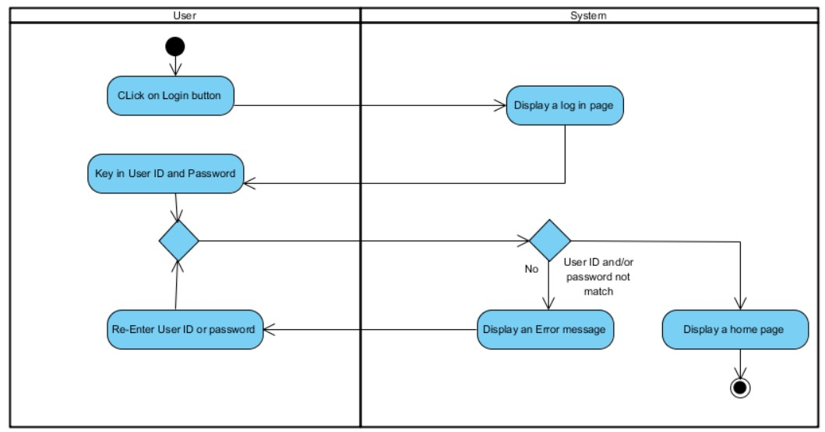

## Search Books

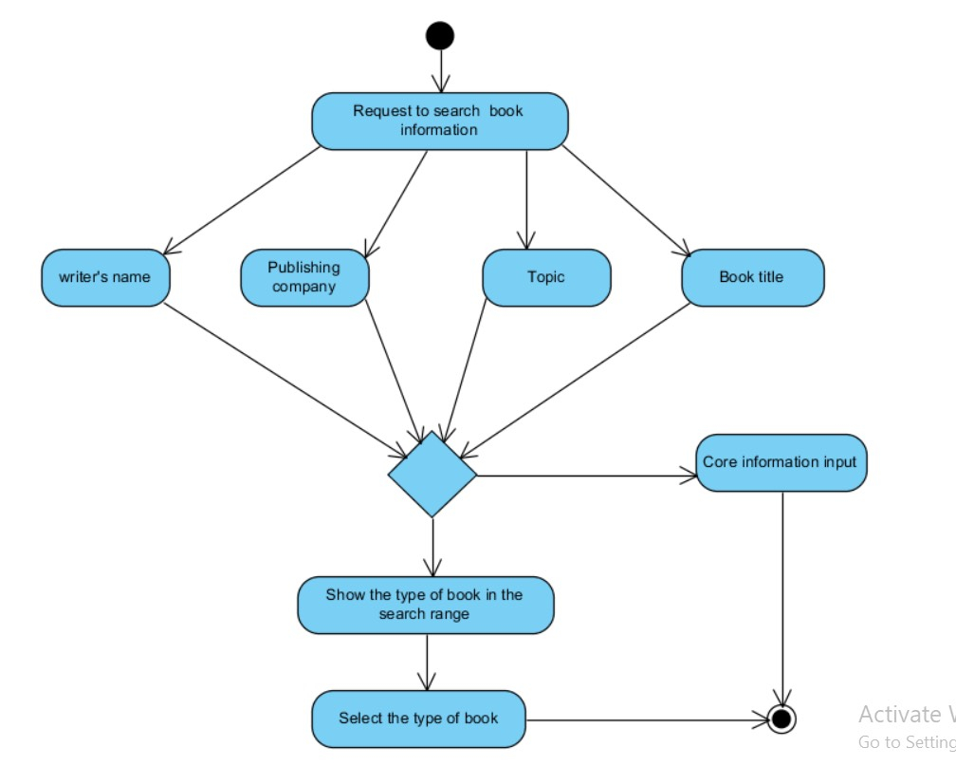

# Appendix A: Glossary

|  |  |
| --- | --- |
| FR | **Functional Requirement** |
| QA | Quality Attribute |
| UC | Use case |
| BR | Business rule |